Ms word

1. Table Operations

1.1 Creating a Table

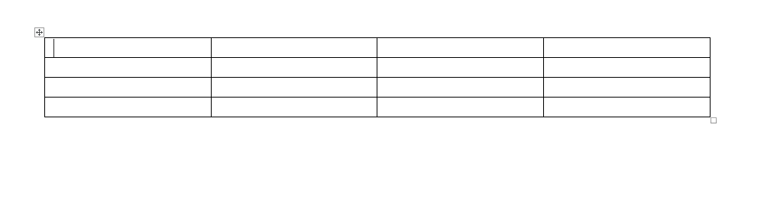

1.2 Inserting Rows and Columns in a Table

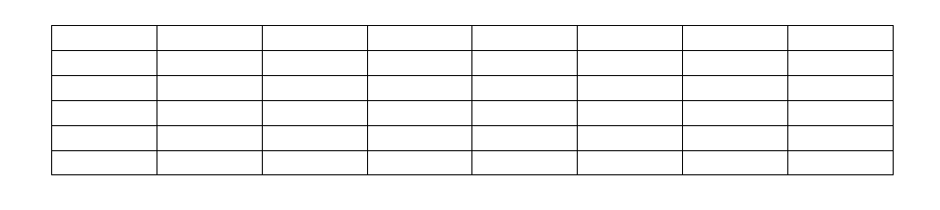

1.3 Deleting Rows and Columns of a Table

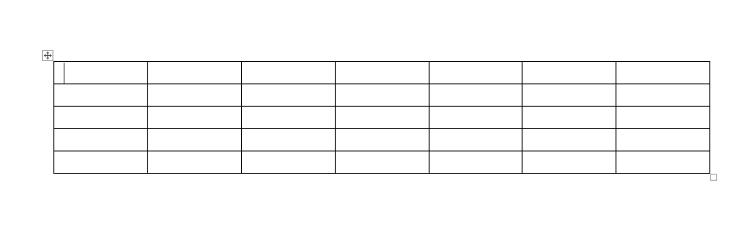

1.4 Merging Cells

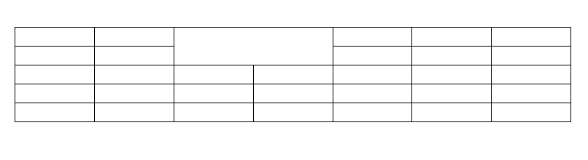

1.5 Splitting Cells

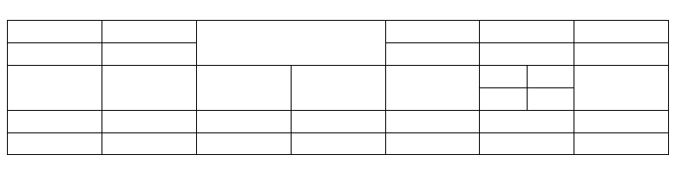

1.5 Changing Direction of Text in a Cell

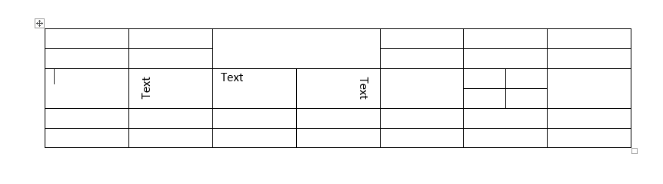

1.6 Apply Shading to Cells, Rows, and Columns

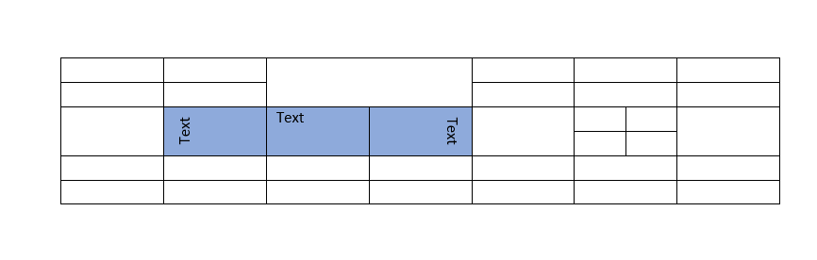

1.7 Apply Borders to Cells, Rows, and Columns

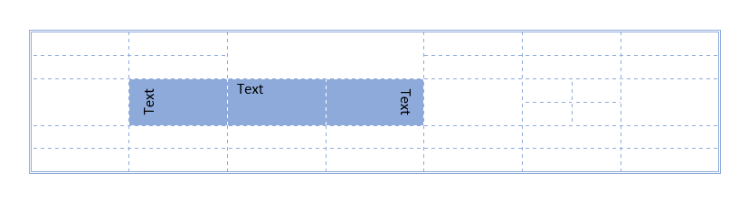

2. Apply Borders to a Page

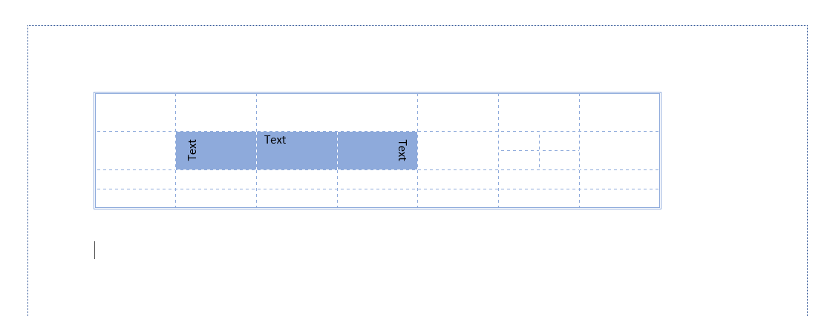

3. Apply Header, Footer and Page Numbers



4. Inserting Symbols

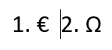

5. Inserting Equations

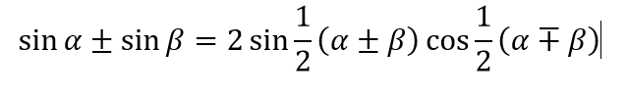

6. Insert Image



7. Inserting Bullets and Numbering

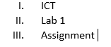

Excel

9. Create Formula

Addition

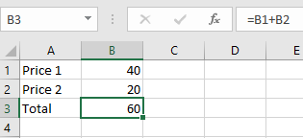

Subtraction

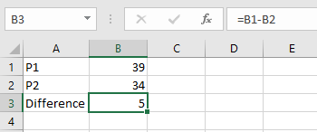

Multiplication

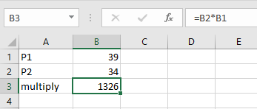

Division

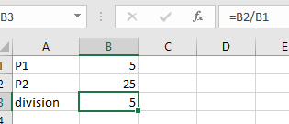

Exponents

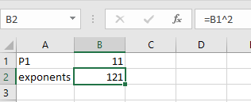

10.1 Creating a Function

Sum

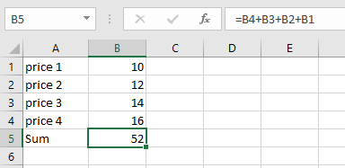

Average

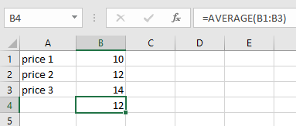

Count

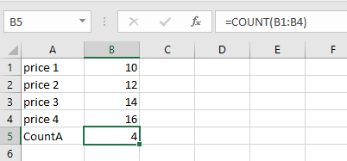

Max

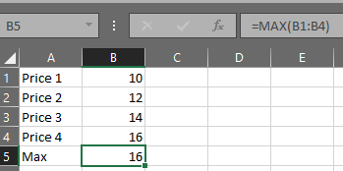

Min

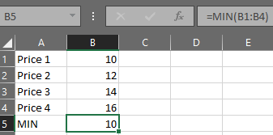

10.1 Creating a Function using the AutoSum Option

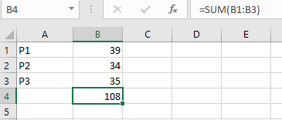

10.2 Inserting a Function from the Function Library

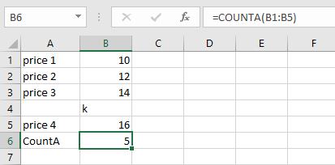

11. Logical Functions

11.1 IF

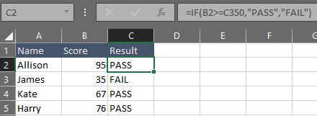

11.2 AND

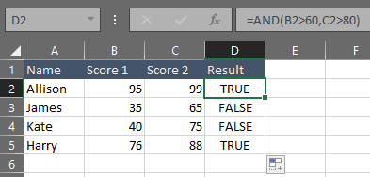

11.3 OR

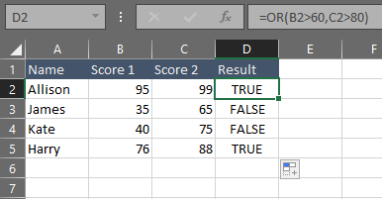

11.4 NOT

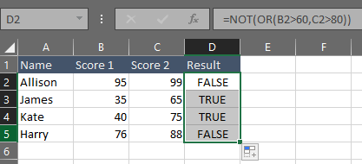

12. Freeze Rows

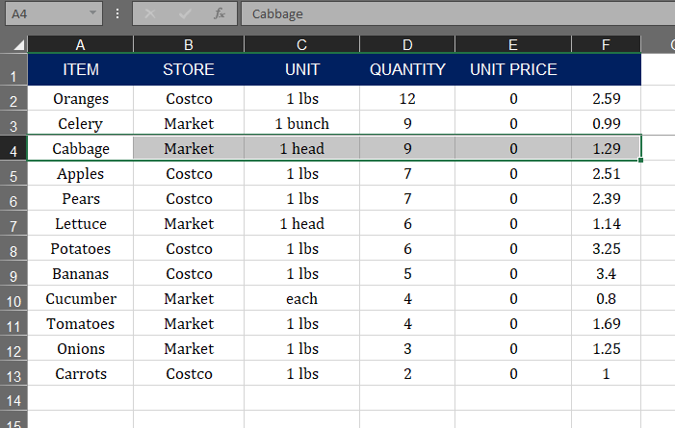

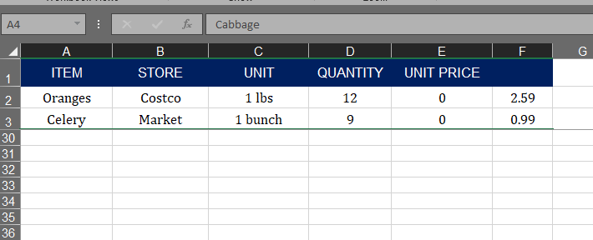

13. Sorting a Range

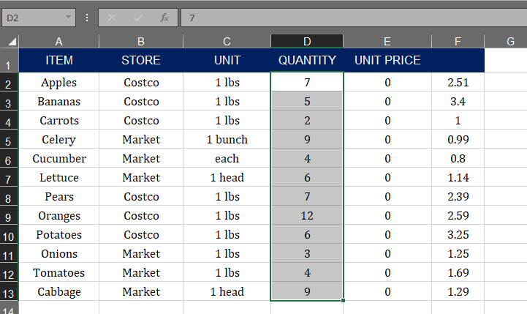

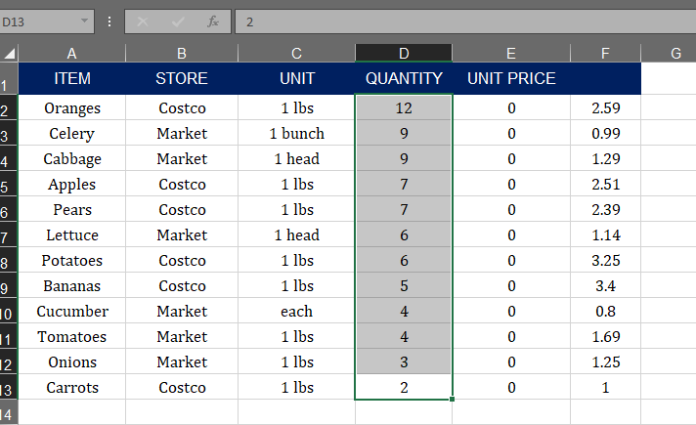

14. Charts in Excel

